**select** k.vbeln **as** Purchase_Order, k.ernam, k.kunnr, p.posnr, p.matnr, p.netwr, p.waerk,

**case**

**when** p.netwr **between** 1 **and** 1500 **then** 'LOW'

**when** p.netwr **between** 1501 **and** 50000 **then** 'MEDIUM'

**when** p.netwr > 50001 **then** 'HIGH'

**else** 'NA'

**end** **as** grade

**from** SAPHANADB.vbak K

**inner** **join**

sapHANADB.VBAP P

**on** k.vbeln = p.vbeln;

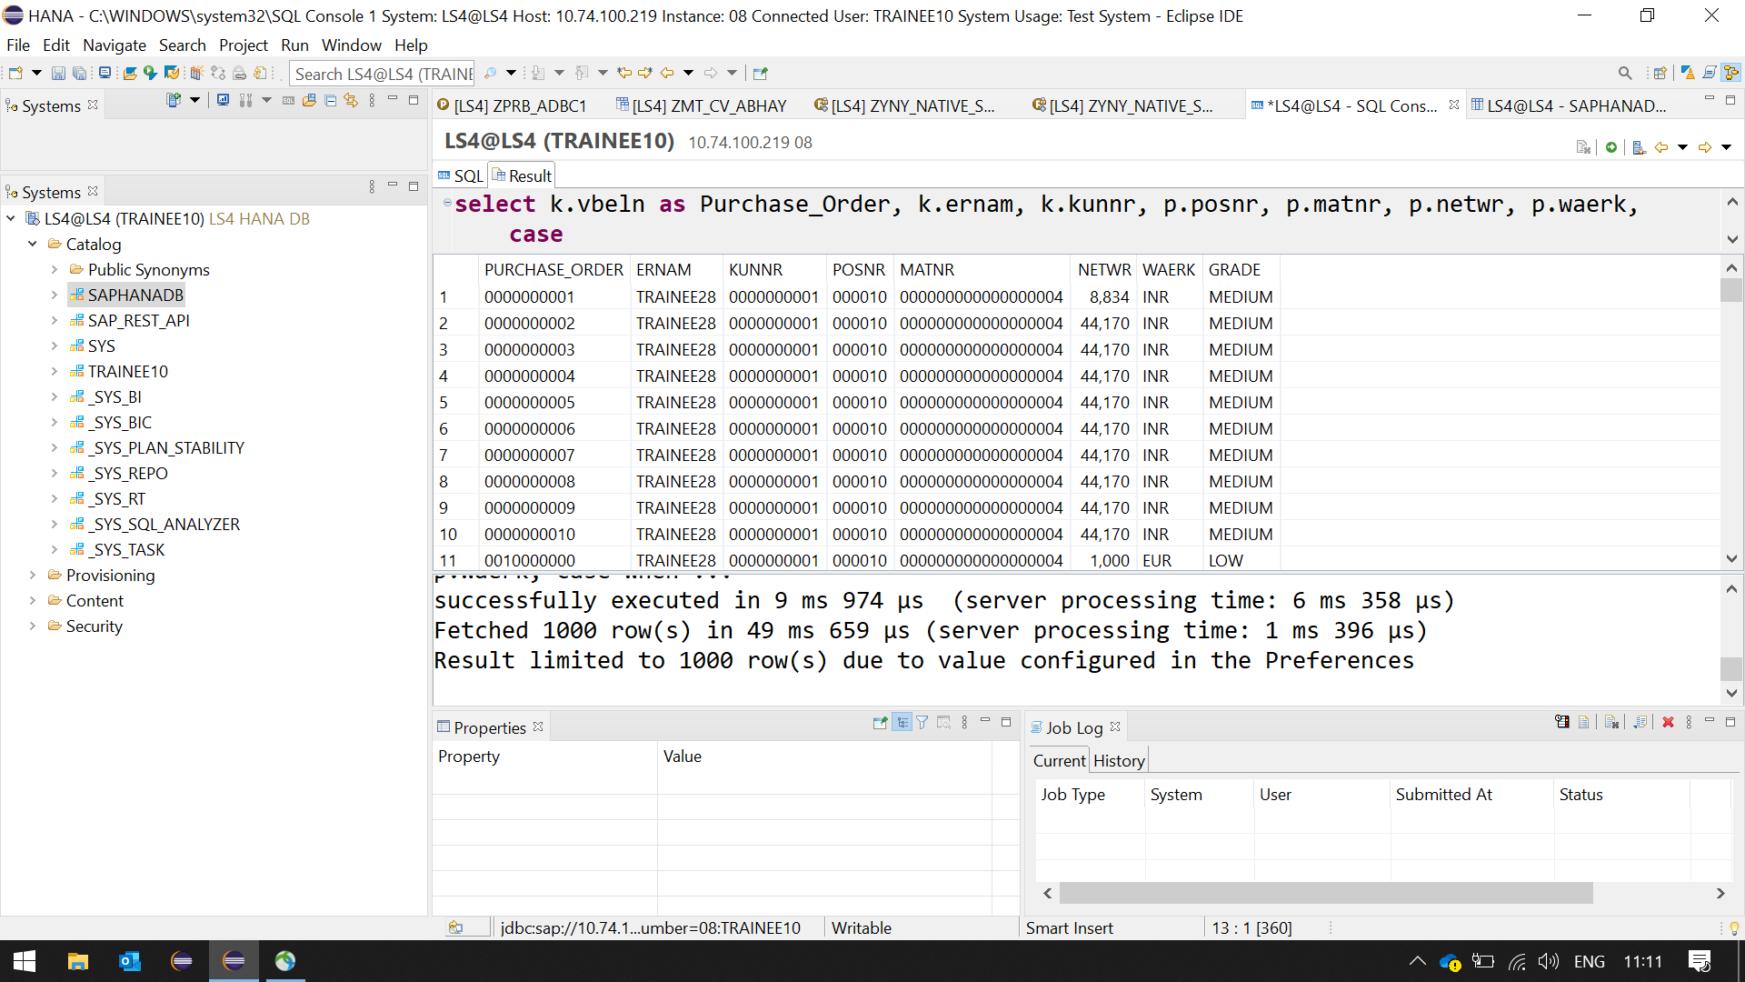

**select**

**Sum**(netwr) **as** Total,

waerk **as** Cur,

werks

**from** sapHANADB.VBAP

**group** **by** waerk, werks

**having** **sum**(netwr) > 10000

**order** **by** waerk, werks;

